Instructions on connecting to Giles Office (RDP) while out.

1. Open any web browser such as: Internet Explorer, Netscape, or Mozilla and type in
http://12.69.33.210:8080/tsweb/
This will be known as (RDP) Remote Desktop Protocol.

A page similar to the following will open.
2. Type in gcsrv or 12.69.33.210 for Server and then click <Connect>.
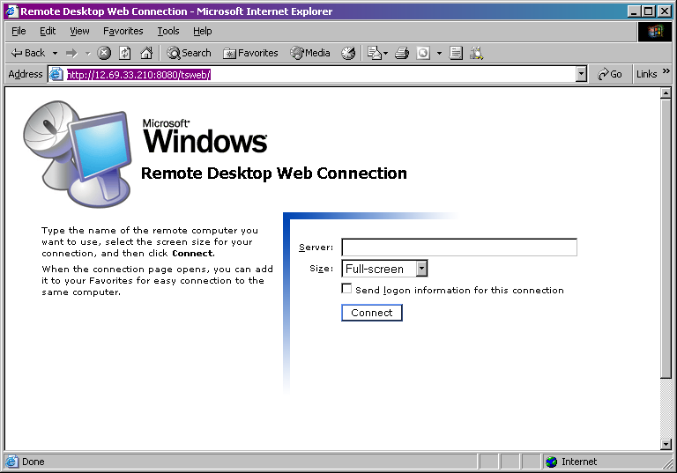

Then a Log On to Windows Server 2003 login window will open.
3. Type in your user name and password
4. Leave Log on to: as GCPREMIER and click <OK>.
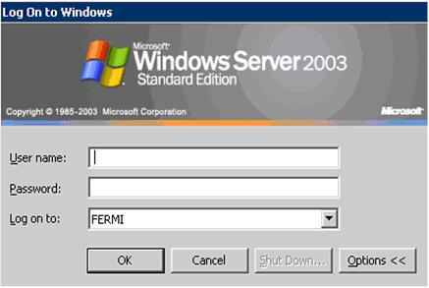

username

******

GCPREMIER

You should now be connected to the Giles network and your desktop.

